
The Washington Informer
Black News, Commentary and Culture | The Washington Informer
POSTED IN EDUCATION
Bloomberg’s Alex Clearfield Wins National Press Club Spelling Bee
by Ashleigh FieldsJuly 2, 2024
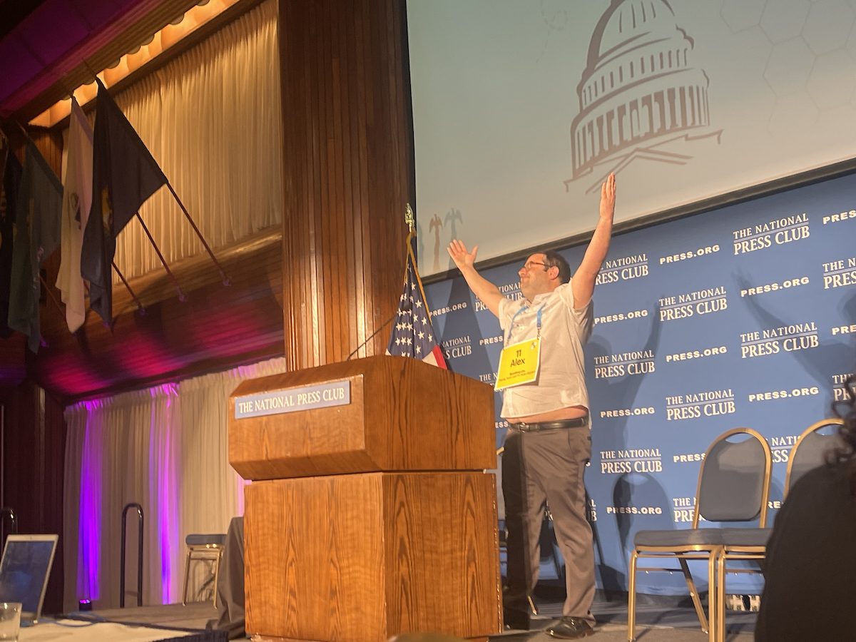Alex Clearfield of Bloomberg Law holds the trophy for the annual Press vs. Politicians Spelling Bee at the National Press Club. (Ashleigh Fields/The Washington Informer)

Journalists and members of Congress tested their knowledge of the American language and familiarity with the dictionary on June 27 during the annual Press vs. Politicians spelling bee at the National Press Club. Scripps National Spelling Bee champion Bruhat Soma attended and served as a judge for participants ahead of the highly anticipated presidential debate.
The team of press spellers included Emily Wilkins, president of the National Press Club, Azi Paybarah of The Washington Post, Alison Fitzgerald Kodjak of ProPublica, Ben Nuckols of The Associated Press, Jessica Mendoza of The Wall Street Journal and Alex Clearfield of Bloomberg Law, who spent the night quailing over spelling strategies rather than debate controversies.
Weeks of preparation proved to be of benefit to Clearfield who successfully conquered uncommon words like waterzooi with ease.

“I knew waterzooi because it was played in a Scrabble video I recently watched,” Clearfield posted on X after the big win.
Wilkins used the platform to make political statements on the current state of detained reporters internationally. When she didn’t readily know the spelling of a word, Wilkins passionately spelled out the phrase “Free Austin Tice.” Tice, a freelance journalist and former marine, has been held captive for 12 years in Syria after an unexpected kidnapping.
Many believe he is being held by the Syrian government. The press club features a scrolling slide dedicated to bringing Tice home, tracking the days of his imprisonment.
“We fight for the rights of reporters,” Wilkins said in her opening remarks. “This includes the American journalists who are detained overseas, Austin Tice, Evan Gershkovich and Alsu Kurmasheva.”
Event sponsor Robert Weiner of Weiner and Associates celebrated the work of the National Press Club Journalism Institute.
“The National Journalism Institute of the National Press Club finds and features issues about journalism: who’s fact checking whom, what is truth versus disinformation, who’s getting hired and fired by which media and who is covering what about which subject, including the presidential race, and more,” said Weiner. “I’m so proud of the National Press Club’s Journalism Institute, its president, Gil Klein, whom I’ve known and worked with for a lifetime, and the staff, that it was a natural for me to sponsor them. And the spelling bee is just plain fun.”
This year marked the 11th spelling bee since its return in 2013, an idea sparked by Klein, who formerly served as chair of the organization’s History and Heritage Committee.
“The event started in 1913 with President Wilson and much of his Cabinet in the audience — the secretary of agriculture officiating. More than a thousand people attended, so the bee was moved to the Willard Hotel,” Klein told The Informer citing treasured history between Sen. Miles Poindexter of Washington (R) and a House member who adamantly contested Rep. Frank B. Willis of Ohio on the form of the word hydrocephalus.
As the spelling bee evolved over the past century, the evening remains a cherished time for families, friends and colleagues to gather in good spirits.
Rep. Ashley Hinson (R-Iowa) celebrated her birthday while participating on stage next to Donald S. Beyer Jr. (D-Va.), whose family cheered him on from the front row.
In a post on X, Beyer referenced the bee as, “one of the great periodic confrontations in American politics, an epic contest of wit and will.”
The politician team consisted of additional lawmakers Suzanne Bonamici (D-Ore.), Chris Papas (D-N.H.) and Hillary Scholten (D-Mich.).
Eric Sorensen (D-Ill.) could not attend due to illness but fellow congress members managed to put up a competitive fight for the title without him.
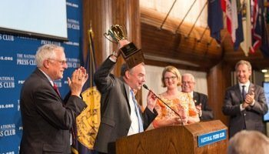
ASHLEIGH FIELDS
ashleighcarringtonfields@gmail.com

Ashleigh Fields is an award-winning journalist specializing in coverage of lawmakers at the White House and on Capitol Hill. Her reporting has earned recognition from the Society of Professional Journalists, the White House Correspondents' Association and the National Association of Black Journalists. Fields is a proud graduate of Howard University where she formerly served as the editor-in-chief of The Hilltop, a campus newspaper founded by Zora Neale Hurston.

