

Opinion |

Commentary: To win new space race, we need…

OPINION

Commentary: To win new space race, we need political will
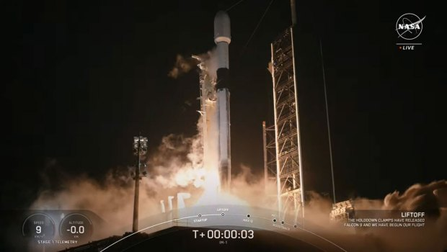
A SpaceX Falcon 9 launches on the IM-1 mission from Kennedy Space Center’s Launch Pad 39-A on Thursday, Feb. 15, 2024 taking Houston-based commercial company Intuitive Machines’ Nova-C lunar lander Odysseys headed for the moon. (Courtesy/NASA)

By ROBERT WEINER AND TING CUI



PUBLISHED: February 15, 2024 at 12:20 p.m. | UPDATED: February 16, 2024 at 9:34 a.m.
After a failed lunar landing mission by Peregrine last month, NASA put its hopes on a second spacecraft developed by SpaceX and Intuitive Machines.
The endeavor, known as the IM-1 moon mission, saw the Nova-C lander named “Odysseus” or “Odie” lift off from the Cape Canaveral Space Force Station at 1:05 a.m. EST on Thursday. If successful, Odie could become the first U.S.-built lunar lander on the moon since the Apollo 17 mission in 1972 — nearly 52 years ago.
25p)
225p
Recent launches are a small step in the right direction, but they’re not enough. We require greater commitment from the United States to uphold our leadership in space.
The last lander, Peregrine, launched by Astrobotic Technology, exploded over the Pacific due to fuel leaks.
The timing of the Peregrine and Odysseus launches has raised questions. These launches were scheduled during hours when few would tune in. This contrasts a time when the Apollo 11 moon landing captivated an estimated 150 million viewers — even the spectacular Super Bowl LVIII ending drew only 123 million viewers.
Better late than never to get to the moon, Mars, and beyond. To beat China, Russia, India and Japan in the new Space Race, we need political will to get back to where we were 50 years ago.
Don’t be fooled by the latest private launches. NASA announced last month that its Artemis II mission, the latest endeavor in the national space program aimed at returning astronauts to just the moon — not beyond — will be postponed to September 2025 or even 2026 after numerous challenges.
China, Russia, Japan and India may be laughing at our latest lunar attempts. These four nations have now accomplished successful soft landings on the Moon. They could outpace America in returning to the lunar surface and venturing onward to Mars and Venus.
Longtime aviation specialist Miles O’Brien told CNN on Jan. 8, as the first unmanned moon-landing mission in 54 years took off, that the earlier moon missions five decades ago were “ahead of our time.”
Astronauts Mark Kelly and Col. Terry Virts, even in 2015 in an appearance at the National Press Club, said that the reason the U.S. did not continue manned space missions to Mars was because of a “lack of political will.”
The United States government spent $6.13 trillion in 2023, of which $25.4 billion — just 0.4% — was provided to NASA. NASA’s budget has stayed at less than 1% of the federal budget for more than 30 years after peaking at 4% under President Nixon when we took our first step on the moon.
We have spent countless trillions of dollars on failed wars with wasted results, but nowhere near what we need to accomplish manned science in other parts of our universe. Space exploration could have amazing givebacks in resources and knowledge. If nuclear fission inspires everybody as much as it does, who knows what’s out in space? What’s the energy that fuels the universe?
China landed a rover on Mars in May 2021, built and launched a space station with a shuttle, and became the only country to land on the far side of the moon. They intend to be the second country to land astronauts on the moon and the first country to ever build a research base on the moon’s south pole by 2040. NASA administrator Bill Nelson, former astronaut and Florida’s U.S. senator for 18 years, has referred to China as “a very aggressive competitor.”

On Feb. 14, Russian advancements in developing a new space-based nuclear weapon were disclosed by current and former officials who were briefed on the matter. This weapon could threaten America’s satellite network, and pose risks to civilian communications, space surveillance, and military operations.
Just as in 1961 when Russia first rocketed Gagarin into orbit and John F. Kennedy committed the U.S. to landing on the moon, the U.S. will feel pressured to catch up.
Congress now has every reason to find the political resolve it needs to allocate funding for these crucial projects. Investing in our interstellar capabilities is crucial for preserving the United States’ national security in space.
Joe Biden must recreate the U.S. vision, as John Kennedy said back in 1962, “not because it is easy, but because it is hard.” America needs a resurgence of our collective aspirations for the Moon, Mars, and beyond — or else other countries will beat us to it.
Robert Weiner was a spokesman in the Clinton and George W. Bush White Houses, and Chief of Staff for Florida Rep. Claude Pepper. Ting Cui is a policy analyst at Robert Weiner Associates and Solutions for Change.

